Pur bad **Permanent address:**

# CURRICULUM VITAE

MAHMUDA AKTER JHUMA

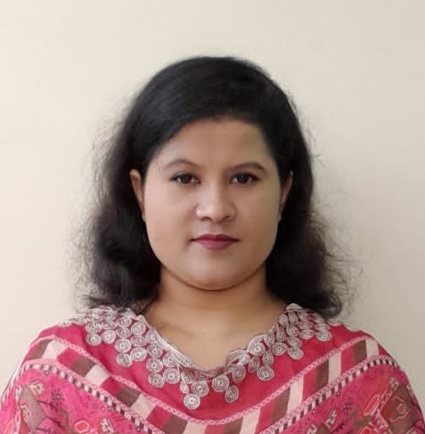

CONTACTS

**Present Address:**

 Mymensingh

+8801754219926

Mail02-RoundedBlack-512[Mjhumu611@gmail.com](mailto:Mjhumu611@gmail.com)

**Permanent Address:**

**Dhaka**

**CAREER OBJECTIVES**



As a student, I am constantly eager to put my skills to use in optimizing processes, assuring product quality, increasing process efficiency, and raising an organization's overall productivity. Through efficient skills and teamwork, I want to contribute to increasing the value of my organization in our society.

**HARD SKILLS**

* MS WORD
* MS EXCEL

**SOFT SKILLS**

* Quick Learner
* Counseling
* Problem solving

# EDUCATION

## Bachelor of Social Science(BSS)

**National University**

Department of Social Work

CGPA- 3.15 out of 4.00



## Higher Secondary Certificate (HSC)

## Mymensingh Central College

## GPA- 3.42 out of 5.00

Science

Dhaka Board

## Secondary School Certificate

## Purbadhala J.M Pilot High School, Purbadhala.

GPA- 5.00 out of 5.00

Science

Dhaka Board

# WORK EXPERIENCES

# Science Teacher: 01-03-2018 to 12-03-2019

# Responsibilities:

# A full curriculum according to above mentioned institution

# Took part in the educational process of students from class 6-10

# Help class students improve final test score by 20%

# Maintain a positive student-teacher relationship

# TRAINING ACTIVITIES

## Field Work Internship-60 Days

**ASPADA Paribesh Unnayan Foundation**, Mymmensingh

## Field Work Internship-60 Days

Upazila Youth Development Office, Trishal, Mymensingh

# EXTRA-CURRICULAR ACTIVITIES

1. Creative writing
2. Handicraft Making

**REFERENCES**

**Md.Mizanur Rahman**

Assistant Professor

24th  BCS Batch

Department of Social Work

Relation: Teacher

**Contract**: 01718904582

.